**DRC: Progress Report**

**Title: “A New Approach to Disrupting the Onset of T1D**"

**PI:** Rizwan Ahmed, PhD, Hopkins

**Specific Aims:** My project is based on our findings that a predominant surface immunoglobulin (BCR) of X cells from T1D individuals bears an autoantigen (x-autoantigen) that can cross-activate autoreactive autologous T cells, including insulin specific CD4 subset. It does this when complexed with HLA-DQ8 molecules and soluble intact mAb, which is of IgM isotype (x-mAb/IgM) and can activate the same subset of T cells. Despite the severe limitations imposed upon us by COVID-19 pandemic, I have been able to make significant progress in accomplishing the three goals of my project. Here is a brief summary of these findings:

**Specific Aim 1.** **Test the hypothesis that IgMpos T cells are enriched for islet-reactive T cells**

The goal of this Aim is to identify x-mAb-interacting T cells and characterize their antigen specificity, phenotype and functional characteristics. As described in my previous summary report, I have shown that the naturally occurring x-mAb can recognize a subset of T cells (that includes both CD4 and CD8 T cells) in patients with T1D. Although x-mAb can recognize some T cells in healthy controls (HCs), the percentage of bound cells was significantly higher in T1D patients. **(Figure 1)**. Thus, given that IgM-binding T cells include insulin –specific T cells, the results suggest that x-mAb could potentially be used to identify insulin-autoreactive CD4 T cells in T1D subjects. In the future, we will examine specificity of IgM-binding CD8 T cells.To directly examine whether there are overlap between insulin-reactive and x-idiotype autoantigen (referred to as x-Id) CD4 T cells, I generated two sets of HLA-DQ8 tetramers using two fluorochrome (PE and APC). One set is loaded with x-id (called DQ8/-x-id tetramer) (x-Idiotype), the set second was loaded with insulin-mimotope (DQ8/-Ins-Mim)) [1]. DQ8 tetramer loaded with CLIP peptide were used as negative controls. We used the x-Id and Ins-Mim tetramers for dual staining of PBMCs from patients with T1D. Our results show that majority of positive CD4 T cells were co-stained with both tetramers. These novel results provide first direct evidence the x-id and insulin autoantigens are recognized by the same population of CD4 T cells **(Figure 2)**. However, besides the commonly identified subpopulation, we detected minor subpopulations of CD4 T cells that are recognized by the tetramers in mutually exclusive manner **(Figure 2)**. We plan to examine specificity of very small nonoverlapping insulin specific CD4 T cells that are not recognized by x-id tetramer. In addition, there are small low binding subpopulations that interact with x-id tetramer but not Ins-Mim tetramer. We will investigate further and determine whether they recognize other islet autoantigens (e.g. GAD65, IA2A, ZnT8 etc.). If so, the results will show a universal autoreactivity of x-id-DQ8 against islet autoantigens (**2)**. This intriguing result raises the possibility that x-mAb reactive T cells could be useful for assessing T1D disease activity. In addition, our tetramer analysis leads us to expose that the shared overlapping population between x-mAb and insulin-mimotope also harbors a minor subpopulation of X cells along with majority of conventional autoreactive T cells. Results show shared subpopulation of X cells (the major population) are stained with both tetramers. Similar to tetramer binding to conventional CD4 T cells, we also detected minor subpopulations of X cells cells that are recognized by the tetramers in mutually exclusive manner. For identifying the X cells population, the cells were stained with TCR and IgD markers. Furthermore, results also highlighted the tetramer binding X cells are enriched (around 7-fold) compared with binding conventional CD4 T cells indicating their enhanced insulin self-reactivity properties.

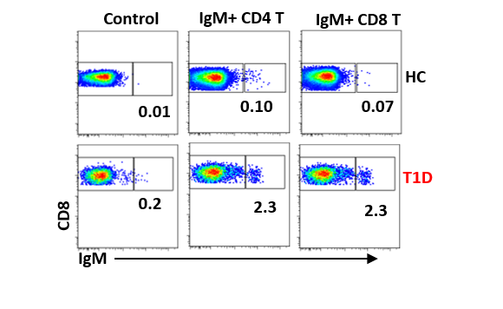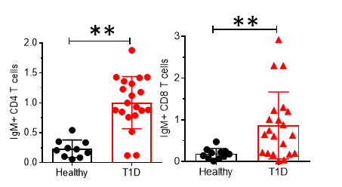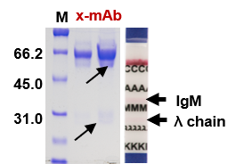

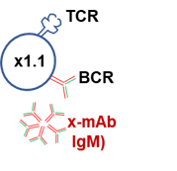

**Figure 1:**  **Use of x-mAb to detect autoreactive CD4 and CD8 T cells:** Diagram, **Coomassie-blue-stained gel** shows production of x-mAb by the x1.1 clone. Arrows points to heavy and light chains of x-mAb (of IgM isotype). **Representative dot plots** show the frequency of x-mAb binding to CD4 T cells (left and (**B**) CD8 T cells among PBMCs from in HC and T1D subjects. Graph shows the cumulative data of 21 T1D and 10 HC subjects; *p < 0.05 by two-way ANOVA.

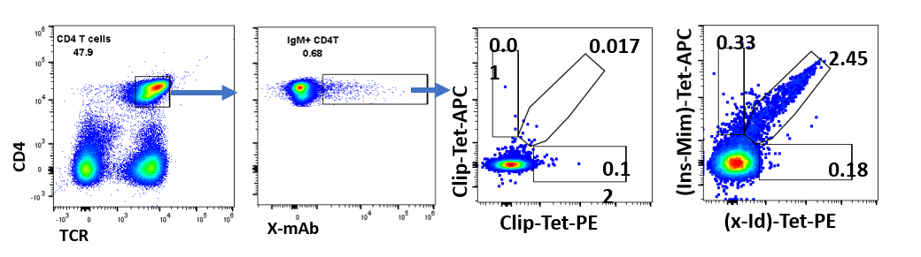



**(C)**



**(B)**

**(A)**

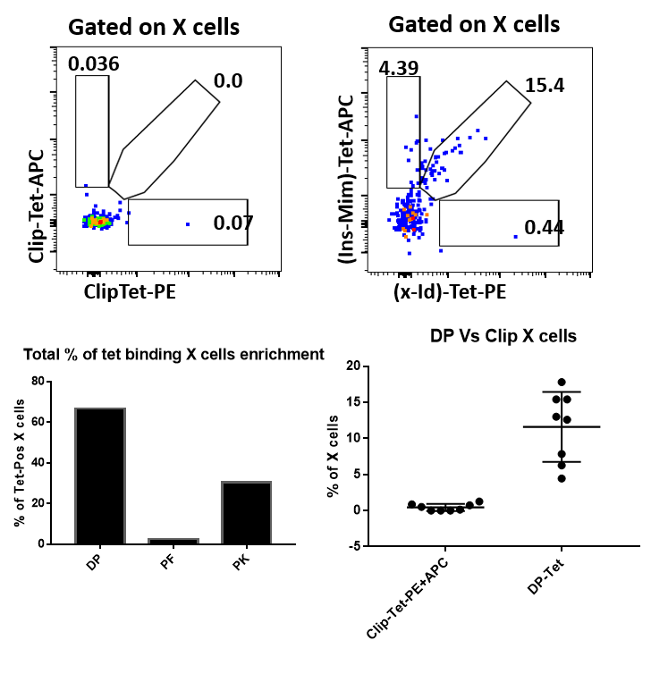

**(D)**



**(G)**

**(F)**

**(E)**

**Figure 2: x-autoantigen (x-Id) and Insulin-mimotope recognize overlapping CD4 T cells.** (**A**) Representative dot plots showing sequential gating and analysis of binding by dual x-Id:DQ8 and Ins-Mim:DQ8 tetramers by CD4+ T cells from 8 T1D patients. and CLIP-DQ8 tetramer binding was used as negative control. (**B**) Graph shows the cumulative data of tetramer-binding CD4 T cells: DP, dual positive for both x-Id and Ins-Mim tetramer, PF; x-Id-Tet binding CD4 T cells and PK; Ins-Mim binding T CD4 cells. **(F)** Graph shows the enrichment of CD4 T cells in T1D that is dual positive for both tetramers compared with negative control CLIP Tetramer staining. **(D-F)** Graphs show dual tetramer binding by gated X cells. **(G)** Graph showing the comparison of percentage of enriched dual positive CDT T cells and X cells. Each dots represents one donor in all the graph shown here.

**Data showing immunogenicity of the invariant CDR3 motif of x-mAb regardless of the flanking amino acids**

Our published simulation results identified the anchor residues of the core CDR3 motif of x-mAb, highlighted in blue (**CARQEDTAMVYYFDYW**) that bind to DQ8 binding pockets. The high affinity is attributed to aspartic acid (D) residues that bind to pockets 1 and 8. In addition, tyrosine residues (Y) also play critical roles by binding to pockets 6 and 7. Interestingly, we detected many antibodies in public database from T1D patients that have the same motif. We determined whether CDR3 peptides bearing this core motif antibodies are immunogenic – regardless of flanking residues at the N-terminal end which also could be immunogenic. To test this possibility, we selected BCR clonotypes from T1D using online sequences at the nPOD-JDRF BCR-TCR data-base (http://clonesearch.jdrfnpod.org/). I synthesized corresponding peptides **(Table 1)** and examined their autoantigenicity using PBMCs from T1D patients (n=7). We stimulated PBMCs cell cultures with peptides and analyzed their proliferation using CFSE assay. I also assessed activation by examining CD69 upregulation. The results show that different CDR3 peptides were able to stimulate the proliferation and led to significant upregulation of CD69. The results are comparable to those generated using x-id and insulin mimotope **(Figure 3)**. These results further validate and extend our previous findings that antibodies-expressing the core x-autoantigen motif could be important sources of idiotype-derived neoantigens.

**(A)**

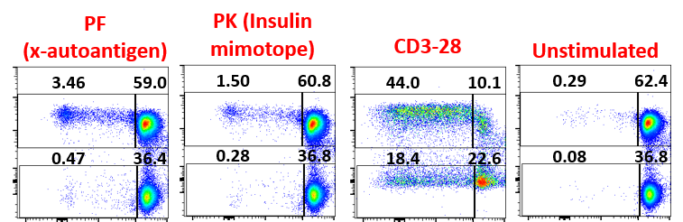

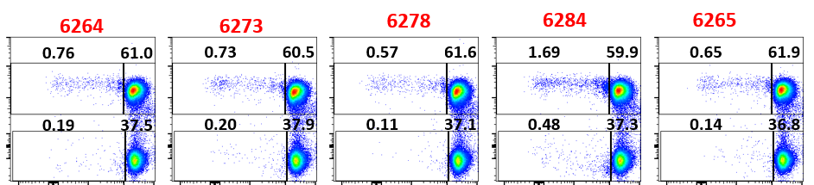

**(B)**

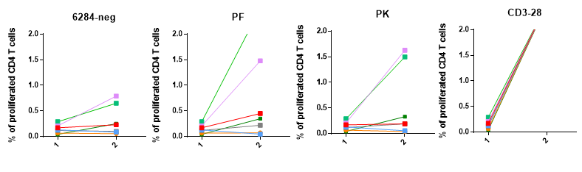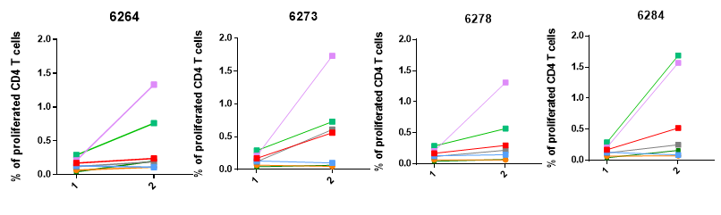

**(C)**

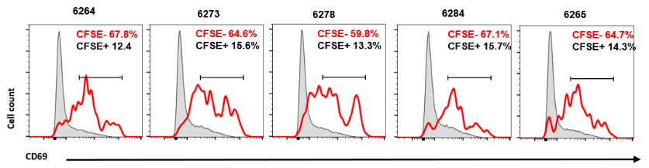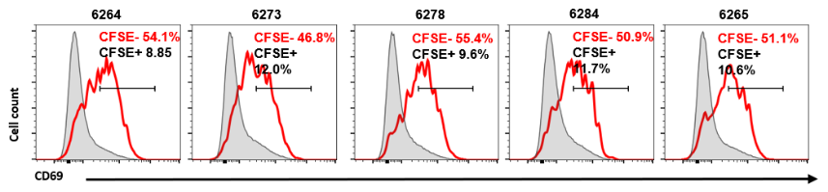

**(D)**

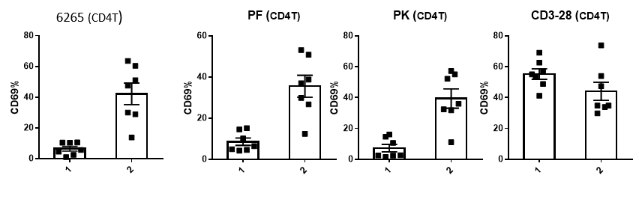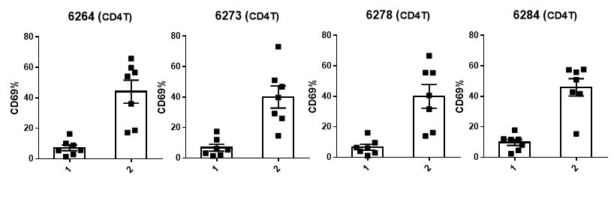

**Figure 3:** **The x-autoantigen has potent ability to activate CD4 T cells regardless of flanking residues.** Representative dot plots show CFSE dilution by gated CD4 T cells among PBMCs from in T1D subjects that were stimulated with indicated peptides. Numbers indicate percentages of gated CFSElow CD4 T cells. **(B)** Graph shows cumulative data from T1D patients (n = 7); *p < 0.05 by two way ANOVA with Sidak’s multiple comparisons test. (**C**) Overlays show upregulation of CD69 by gated CFSElow CD4 T cells (red line) versus non-proliferating CFSEhi CD4 T cells (gray line) in each subject group. Numbers indicate the representative percentages (mean ± SEM) of CFSElow CD4 T cells. (**D**) Graph shows the cumulative percentage of upregulation of CD69 by gated proliferated CFSElow CD4 T cells versus non-proliferated CFSEhi CD4 T cells.

**Table 1:** Detection of x-Id motif (**DTAMVYYFDYW**) in BCR clonotypes at nPOD samples using nPOD TCR/BCR search tool

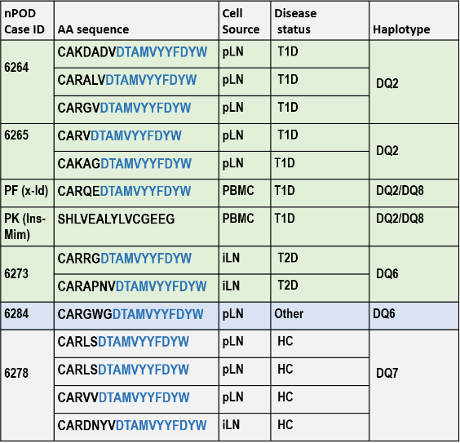

1. **Define differentiation programs exhibited by IgMpos CD4 T cells as compared to IgMneg CD4 T cells.**

In this study, we have examined the activation phenotype of x-mAb reactive T cells and compared the profile with non-binders. In my previous report, I showed that the majority of x-mAb reactive CD4 T cells possess memory phenotype by expressing CD45-RO expression compared to naïve phenotype (CD45-RA). To further categorize the activation phenotype of CD4 T cells (CD4+ T effector memory [TEM] CD4+ T central memory [TCM], and naïve CD4+ T cell [TNaïve]), I performed flow staining based on expression of marker CD45-RO and CCR7. TNaïve CD4+ T cells were defined as CD45RO−CCR7+, TEM CD4+ T cells were CD45RO+CCR7−, and TCM CD4+ T cells were CD45RO+CCR7+. Of the x-mAb-specific cells from patients with T1D, 73% were antigen-experienced central memory cells, with TCM 61% (CD45RO+CCR7+) and 12% TEM (CD45RO+CCR7−) phenotype ([Figure 4.](https://diabetes.diabetesjournals.org/content/66/12/3051#F3) ). In contrast, for non-binder cells (IgMneg) from patients with T1D, 58.4% were antigen-experienced central memory cells, with TCM 40.7% (CD45RO+CCR7+) and 17.7% TEM (CD45RO+CCR7−) phenotype ([Figure 4](https://diabetes.diabetesjournals.org/content/66/12/3051#F3) ). Further, I also evaluated CXCR3 and CCR7 expression and determined that 50% of x-mAb reactive CD4 T cells express CXCR3 receptor compared to 16% IgMneg (non-binder) CD4 T cells. Additionally, almost all the population (96%) of x-mAb reactive T cells express CCR7 compared to 56% IgMneg (non-binder) CD4 T cells **(Figure 4A-C)**. In the case of T1D, our preliminary result indicated the majority of x-mAb reactive CD4 T cells were more biased toward antigen experienced memory phenotype as compared to non-binder cells – indicating that autoreactive T cells acquire this phenotype as a result of the disease process. However, we recognize that our analysis is limited to small number of T1D patient samples. Therefore, to verify and validate this result of activation phenotype will essentially be require for further analysis by including more number T1D patients’ samples, which I propose to investigate as a future goal.

1. **Define effector functions of IgMpos CD4 T cells as compared to IgMneg CD4 T cells by examining their cytokines.** It is now well evident from literature that cytokines are major mediators of inflammation and tissue destruction [1]. Effectors known to be involved in T1D can be divided into Th1/Th2/Th17 and one of the ways they carry out their effector functions is by secreting cytokines. Our data (as shown above) highlights that x-mAb reactive CD4 T cells subpopulation are enriched for different differentiation statuses of antigen experienced memory phenotype. Given this, it’s reasonable to test the cytokine profile of x-mAb reactive CD4 T cells and compare their profile with non-binder cells. In this regard, I set up preliminary experiment and evaluated production of intracellular TNFa cytokine in ex-vivo condition using PBMCs samples isolated from T1D patients. In the results, we found that the majority (>94%) of x-mab reactive CD4 T cells upon stimulation with PMA/Ionomycin profoundly secrete TNFa cytokine when compared with unstimulated cells. In parallel, we tested nonbinder cells (x-mAb-neg) that also secrete TNFa cytokines significantly but to a lesser extent as compared to x-mAb reactive T cells **(Figure 4D)**. Additionally, I executed another set of experiments to test the production of cytokines by sorting x-mab-reactive and the nonbinder CD4 T subpopulation. For this, I separated the x-mAb reactive as well as non-binder CD4 T cells by flow cytometry-based sorting using PBMCs samples of T1D. I cultured the sorted cell and analyzed them for presence of the intracellular cytokines (TNFa and IFNy) secretion following stimulation with PMA/Ionomycin using similar approach as described for PBMCs culture. Our preliminary results show that almost all (>95%) of x-mAb-reactive CD4 T cells are potent secretor of TNFa cytokine which is consistent with our cytokine analysis when performed with ex-vivo PBMCS samples. Interestingly, we discovered that there are two discrete population of x-mAb reactive CD4 T cells based on expression IFNy cytokine. Among the two discrete populations of x-mAb reactive CD4 T cells, the majority (up to70%) of x-mAb-reactive CD4 T cells are only secretors of TNFa cytokines. Whereas, the other minor population (up to 35%) are secretor of both TNFa and IFNy. In parallel, sorted non-binder T cells were also investigated for compared analysis to x-mAb-reactive T cells **(Figure 4E)**. The data showed that non-binder cells also secrete the cytokine, but to a lesser extent as compared to x-mAb reactive to CD4 T cells. This observed result is inconsistent with previous reports that show the production of both inflammatory cytokines IFN-y and TNF-a by insulin-specific T cells in NOD mice when they are challenged with insulin autoantigen **(3)**.

**D**

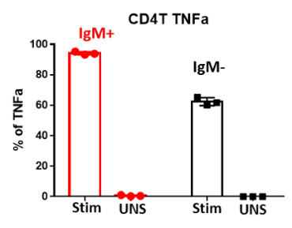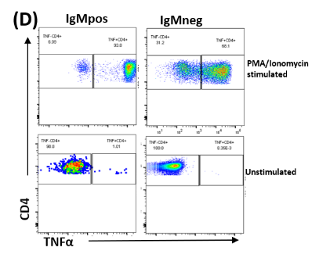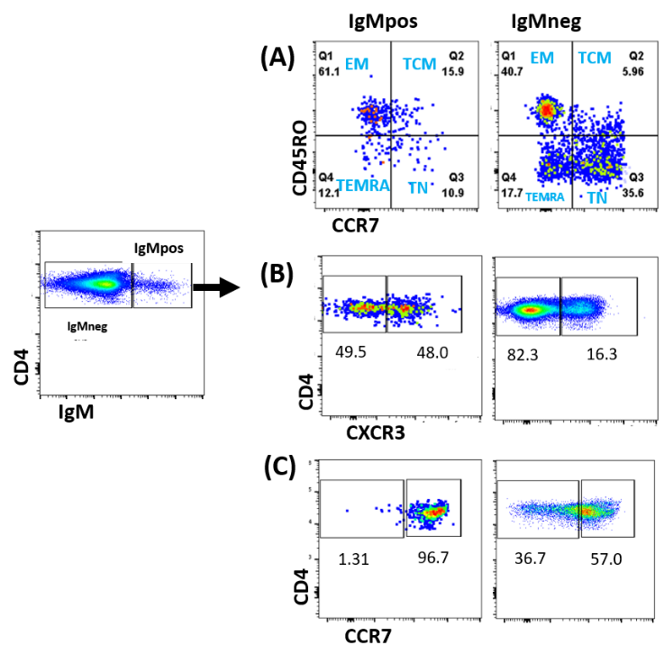

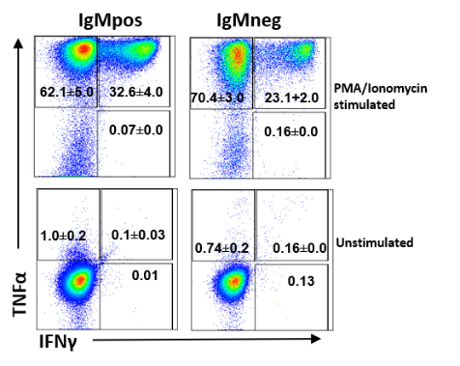

**(E)**

**Figure 4: Ex vivo frequencies and Ag-experienced phenotypes and cytokine profile of circulating x-mAb:** PBMCs were isolated from the T1D patients’ blood sample and were stained with indicated markers. **(A)** Representative dot plot (left) show the gating of xmAb binding (IgMpos) and non-binders (IgMneg) CD4 T cells. Dot plot (right) shows cumulative frequency of naïve and antigen experienced cells (TNaïve CD4+ T; CD45RO−CCR7+, TEM CD4+ T; CD45RO+CCR7−, TCM CD4+ T; CD45RO+CCR7+ and TEMRA CD4+T; CD45RO-CCR7-) out of xmAb binding (IgMpos) and non-binders (IgMneg) CD4 T cells. **(B-C)** Dot plot show the cumulative frequency of chemokine receptor (CXCR3 and CCR7) by the xmAb binding (IgMpos) compared with non-binders (IgMneg) CD4 T cells. **(D)** **Representative Dot plot and graph** show the expression of intracellular TNFa cytokine by the xmAb binding (IgMpos) compared with non-binders (IgMneg) CD4 T cells on stimulation PBMCs with PMA/ionomycin for 4hr. **(E)** **Representative dot plots** show intracellular expression of both TNFa and IFN-g sorted x-mab binding and nonbinder CD4 T cells after stimulation with PMA/ionomycin. The numbers in the plot gate indicate the cumulative ((Mean ± SEM) percentage of respective cytokines from three independent experiments (n=3).

**Aim 2. Test hypothesis that IgMpos CD4 T cells are islet antigen-driven, clonally-expanded subpopulation by a mechanism that involves crosslinking TCR**.

To further link IgMpos CD4 T cells to the diabetogenic process, we: **(a) Test the hypothesis that IgM-interacting CD4 T cells are clonally expanded.** Several autoimmune disorders especially T1D have been linked to autoreactive T cells using T cell receptors (TCRs) with restricted variable chains. Careful analysis of their TCR repertoires provides molecular evidence for the pathogenic role. Considering these facts, in my previous report, I have investigated TCRVB repertoires of x-mAb binding CD4 T cells from a total of six T1D subjects using high-throughput ImmunoSEQ in order to analyze and compare their TCRVβ repertoire to that of non-binder (IgMneg) subpopulation. We have shown a clonal expansion and biased repertoire of x-mAb (IgMpos) binding CD4 T cells compared to non-binder IgMneg CD4 T cells where there is no clonal expansion observed. In addition, I have also shown that, x-mAb binding CD4 T cells used only a few clones for their TCR repertoire formation, indicating oligoclonality with restrictive diversity and limited VB gene usage compared to diverse repertoire of non-binding CD4 T cells. Further, this analysis also highlighted one dominant top clone (CASSETSAGGRYEQYF) that are shared only among x-mAb reactive T cells by six T1D patients. Intrigued by this observation, in my current study, I extended further TCR repertoire analysis of x-mAb reactive CD4 T cells to define their clonality. This new repertoire analysis, lead us to identify three more new clones of x-mAb reactive CD4 T cells. These new clones, like our previously mentioned top clone, are found to be dominant and shared among examined T1D patients. Next, I explored to identify whether all these top 4 x-mAb reactive CD4 T clones are clonally expanded compared to non-binder CD4 T cells. In our analysis, we found that in all 6 T1D patients, the percentage frequency of each x-mAb reactive CD4 T cell clones are significantly higher with several fold compared to nonbinder CD4 T cells strongly suggesting antigen (x-autoantigen) mediated clonal expansion of CD4 T cells which correlating their connection with development of pathogenesis of T1D. Intrigued by this observation, I was interested to see whether we can find similar clonally expanded x-mAb reactive CD4 T cells clones in public available TCR databases. To examine this, in our next goal I interrogated an Insilco database of TCR sequences compiled by high-throughput sequencing of T cells obtained from T1D patients, at-risk aAb+ individuals, and healthy individuals samples submitted to nPOD data repository. The nPOD TCR data base search analysis lead us to identify the wide presence of same x-mAb reactive CD4 T cells clones among different samples (that includes PBMC, Pancreatic lymph node, Spleen and inguinal lymph node) obtained from T1D, T2D patients, as well as from healthy people. Though x-mAb-reactive CD4 T cell clones are present both in healthy and T1D, the frequency is significantly high in cases with T1D diabetes which can explain their clonal expansion and correlates their pathogenic clinical relevance with the disease process. In addition, we also performed data base survey analysis of these clones to examine if they are present in other diseases samples. Interestingly, we found that these clones are not only exclusively present among T1D but also present in patients with other autoimmune diseases (multiple sclerosis, Grave’s diseases) along with cancer patients. Overall, this analysis highlights that x-mAb interacts with specific population CD4 T cells that are autoreactive in nature and constitute universal public TCR on their surface that might be responsible for their clonal expansion and onset of disease process of T1D and other autoimmune diseases.

**(b) Test the hypothesis x-mAb interacts with islet-reactive T cells via crosslinking TCR**

We have shown that x-mAb can bind specifically and activate a specific population of autoreactive T cells in T1D patients. To understand the role of x-mAb and interacting T cells in pathogenesis of T1D, it is necessary to investigate the underlying mechanism of how x-mAb stimulates autoreactive-reactive T cells. For this connection, in our previous report using an immunoprecipitation experiment, our data highlighted that x-mAb can mechanistically bind to T cells by engaging directly to their TCR. This means that x-mAb have specific binding specificity with the TCR present of T cells and that can be conceptually linked to our TCR repertoire data which might explain the reason of why x-mAb reactive T cells population are confined to only a few shared clones among T1D. To further confirm and validate the direct binding of x-mAb and TCR present on T cells, we next executed Insilco molecular structural analysis. To study this, we first built the three-dimension (3D) protein structure model of both x-mAb and TCRb (TCR clone of X cells) based on sequence-to-structure-to-function paradigm. The generated 3D structure of x-mAb and TCR was confirmed to be of good quality with appropriate folded confirmation. The structure highlighted that almost all the residues of protein structure were found to be in favored and allowed regions, and the CDR3 core motif of x-mAb was found to be protruding outside and flexibly exposed for favorable interaction. To test the x-mAb and TCR binding interaction, the built structure was further docked to each other and in-depth structural analysis of docked protein structure revealed several beneficial binding characteristics of this core motif of CDR3 peptide in binding with TCR. We highlighted the importance of the anchor residues (Methionine (M), Threonine(T), Alanine (A) and Aspartic acid (D)) at sites 6, 9, 11 and 14 of the CDR3 core epitope which are clearly visible from contact analyses **(Figure 5)** and make extensive contacts with residues (Glutamic acid (E), Valine (V) and Tyrosine (Y)) at site 5, 10 and 12 of TCR respectively. Taken together, we conclude the strong p–p stacking and hydrophobic interactions from flexible exposed core motif of CDR3 peptide contributed favorably to stronger binding with TCR. Thus, consistent with our immunoprecipitation data, the current molecular Insilco analysis shows that the core motif of CDR3 peptide (x-Id) appears to have optimal anchor residues for binding to TCR which further confirms the ability of x-mAb to binds with high affinity to T cells by engaging directly to their TCR and can play an important role in disease pathogenesis of T1D.

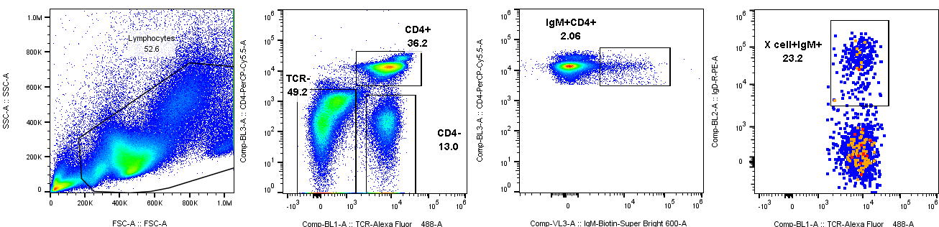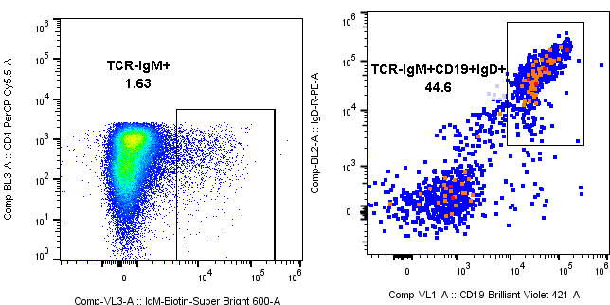

**TCR**

**IgD**

**CD19**

**IgD**

**IgMpos CD4 T**

**X cells**

**(B)**

**M 2 1**

**40kDa**

**25kDa**

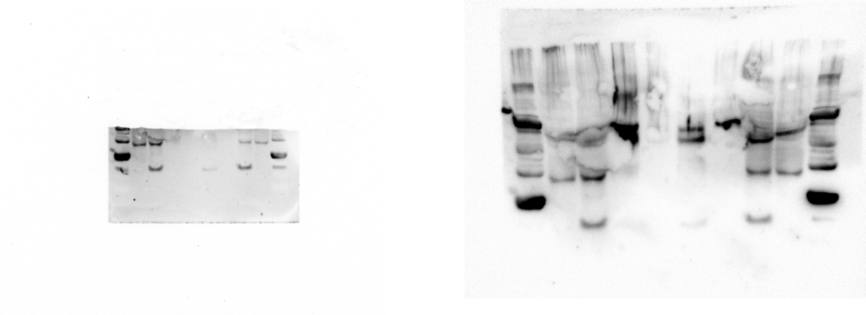

TCRb monomer

TCRb

Dimer

**(A)**

**Figure 5: Immunoprecipitation of TCR using x-mAb. Western-bot** showing the binding of x-mAb to T cells through crosslinking TCR. (Lane1) Indicated arrow shows the immunoprecipitation of TCR chain (dimer at 37kDa and monomer at 17kDa) using x-mAb antibody. (Lane 2) shows the positive control. (M) Protein marker. (B) **Representative dot blot** showing the binding of x-mAb to the TCR of X cells. Detection of X cells that are binding to x-mAb are shown by staining by both (IgM+CD4+TCR+IgD+) or (IgM+ TCR+IgD+CD19+).

**Future Experiment plan:**

1. Phenotype and functional characterization of x-mAb (IgMpos) binding compared to non-binding (IgMneg) counterparts of T cells using flow cytometry.
2. Examine the auto-antigen reactivity of IgMpos binding T cells to islet and other self-antigens.
3. Data Analysis
4. Writing next DRC progress report and Manuscript preparation.

**Reference:**

1. Ahmed, R., et al., *A Public BCR Present in a Unique Dual-Receptor-Expressing Lymphocyte from Type 1 Diabetes Patients Encodes a Potent T Cell Autoantigen.* Cell, 2019. **177**(6): p. 1583-1599 e16.
2. Coppieters KT, Dotta F, Amirian N, Campbell PD, Kay TW, et al. *Demonstration of islet-autoreactive CD8 T cells in insulitic lesions from recent onset and long-term type 1 diabetes patients*. J Exp Med, 2012. 209 (1) : p.51–60.10.1084.
3. Pauken KE, Linehan JL, Spanier JA, et al. Cutting edge: type 1 diabetes occurs despite robust anergy among endogenous insulin-specific CD4 T cells in NOD mice. J Immunol 2013;191:4913–4917